LensCheck User Guide
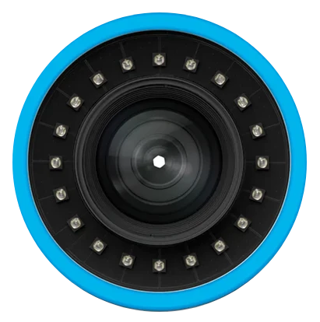

6/2/2026

Introduction
LensCheck is an application designed to assist in the evaluation of camera lens quality using computer vision techniques. This software guides an operator through the capture process, providing objective metrics which can be used to compare lenses, and verify their performance.

Performing a Lens Evaluation

Connect a Camera
- Connect the test camera to the PC via USB or Ethernet connection.

Start LensCheck Software
- The camera will be detected and the video feed will display the camera’s view.

Adjust the Test Environment
- Verify dots extend to image corners and reposition camera as required.
- Adjust camera focus using graph guide until optimal focus is achieved

Well focused image:
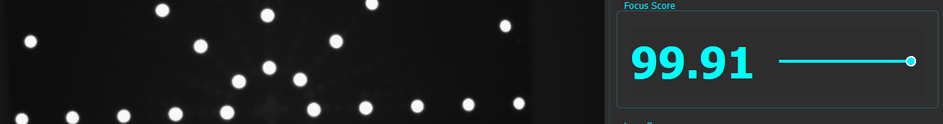

Poorly focused image:
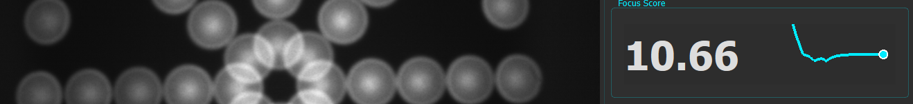

- A perfectly focused image will not always produce a score of 100, depending on environment. Min/max thresholds are set dynamically and are dependent on values seen by software during testing.

For example, if a peak is seen at 25.0 and focus cannot be further improved, 25.0 is the max achievable score. It is suggested a focus sweep be performed by the operator

Configure Test Parameters
- Check that all markers are reliably detected and positioned correctly.
  - If there are markers detected which are not present, lower sensitivity in single steps until all markers are reliably detected, without pop-in or flickering
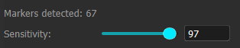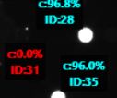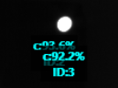

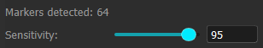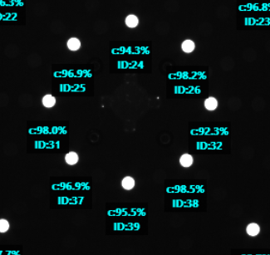

- Even small changes in sensitivity can result in detection improvement!
- Scores are time-smoothed and take a few seconds to settle.

  - If lowering the sensitivity does not reduce the number of markers, try lowering the exposure slightly until the correct number of markers are detected.

- Enter a serial number into the serial field located in the Exporter tab:
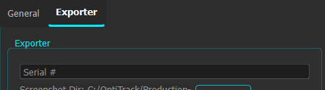

Review/Export Results
- Once a stable frame score and image are displayed, the lens metrics and current camera view may be exported to a file.
- Click ‘Screenshot’ to capture the current view:
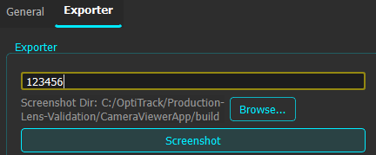

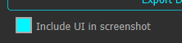
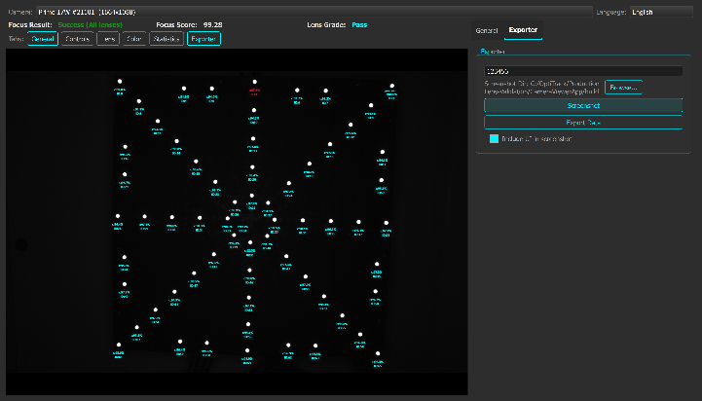
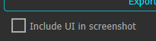
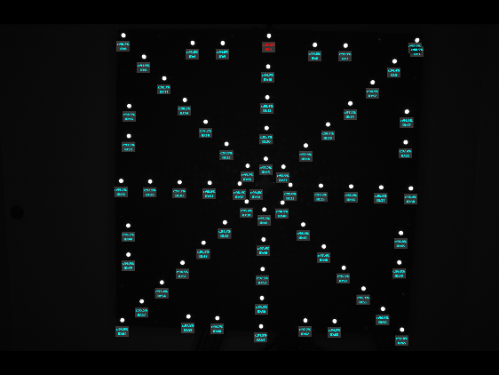

- Click ‘Export Data’ to produce a .csv file containing all visible marker data:

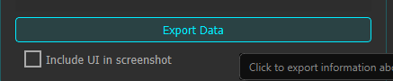

Interpreting Output Data
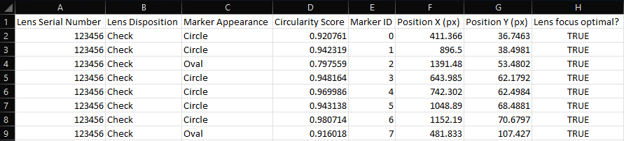
  - Lens Serial Number: Serial number entered by operator for installed lens
  - Lens Disposition: Overall lens score (Check/Pass/Fail)
  - Marker Appearance: Per-marker grade (Circle/Oval/Hook)
  - Circularity Score: Value ranging between 0 and 1.0, indicates how circular a particular marker appears.
    - A perfectly circular marker has a circularity of 1.0.
  - Marker ID: Unique identifier for a marker, which can be correlated with an exported screenshot.
  - Position X (px): Location in image marker occurs, measured in pixels.
    - Not always accurate to true screenshot location, and should only be used as a relative locator for marker dots
  - Position X (px): Location in image marker occurs, measured in pixels.
    - Not always accurate to true screenshot location, and should only be used as a relative locator for marker dots
  - Lens focus optimal?: Indicates whether the lens focus was optimal/passing at the time of evaluation (true/false).

Troubleshooting
- Camera isn’t detected
  - Restart the software and check connections
- Image is too dark/dim
  - Increase exposure as required.
    - If applicable, first adjust exposure on camera lens before increasing software exposure.
    - Avoid increasing gain to increase brightness unless absolutely necessary, as this introduces noise which may negatively affect detection stability.
- Not all markers are detected
  - Check exposure
  - Increase sensitivity in single steps until all markers are reliably detected
- Too many markers are detected
  - Check that exposure isn’t too high, which may cause small reflections to appear as markers.
  - Decrease sensitivity in single steps until only the true marker dots are detected.

Important Constants & Thresholds
- CircleMarkerDetector.h
  - Marker categorization
    - OVAL_UPPER_THRESHOLD = 0.92f;
      - Markers scoring higher than this are circular

    - OVAL_LOWER_THRESHOLD = 0.62f;
      - Markers scoring lower than this are hooks
      - Any number of markers result in a failing lens score

  - Hough + Canny Circle Detection Parameters
struct DetectionParams {
double dp = 1.0; ///< Inverse ratio of accumulator resolution
double minDist = 10.0; ///< Minimum distance between circles
double param1 = 300.0; ///< Upper threshold for Canny edge detection
double param2 = 6.0; ///< Accumulator threshold for circle detection
double minRadius = 1.0; ///< Minimum circle radius
double maxRadius = 30.0; ///< Maximum circle radius
};

